Chapter 10, Problem 13.

Determine V_{x} (see Fig. 10.62), using any method of your choice.

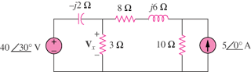

Figure 10.62
For Prob. 10.13.

